India tour 14-30 November 2018
Agra Day 15

Wednesday 28th November 2018
Day 15:- Agra and the Taj Mahal.
The day has finally arrived for our tour of the jewel in the crown of India tourism – The Taj Mahal! This monument to love was completed by Emperor Shah Jahan in 1654. It is a memorial to his beloved Queen Mumtaz Mahal.
Alan was up at 5.30am to check travel case etc for tomorrow’s departure for Delhi, have ablutions an off to breakfast at 7.00am. Buffet style again with Alan’s choice; - mixed cereals, orange juice, green tea, fruit, yoghurt and toast.
The bus departed the ITC hotel by 8.15am. The previous evening there was a plan to get up early and be at the Taj for a photo opportunity to get the sunrise effect on the monument. Alas, Harch, our Indian tour guide advised that there was too much fog & haze around to get beneficial early morning photos so this timing was cancelled.
The group arrived at the Taj complex at 9.00am and joined the hundreds of people flooding through the massive gates. Our tour guide had to purchase the entry tickets for our numbers before gaining entry. An electric cart had to take the tourists to the gate entrance as no other vehicles allowed within 1 k of the complex. He also gathered the group at a point of interest inside the gate and explained the history of the monument and the details of the best photo places.
One and a half hours were spent wandering around this magnificent structure, taking photos from all angles and enjoying the WOW factor. For a visit inside the tomb area one had to get plastic shoe coverings and shuffle through a long line at the entrance. Inside, a tour Waller did a button hold of each small group and explains the various items on view in the dim light (for some rupees of course). One could say “another bucket list item crossed off”!
Exiting the complex was a patience testing time as the group was besieged by flies – hawkers – selling anything from books, postcards to trinkets representations of the Taj Mahal. One offered Father Max a booklet for $US50! That price came down to about $US5 before we re-joined our tour bus. Next stop was for lunch.
Too many photos to include in this journal so a selection of the more relevant ones follows:-
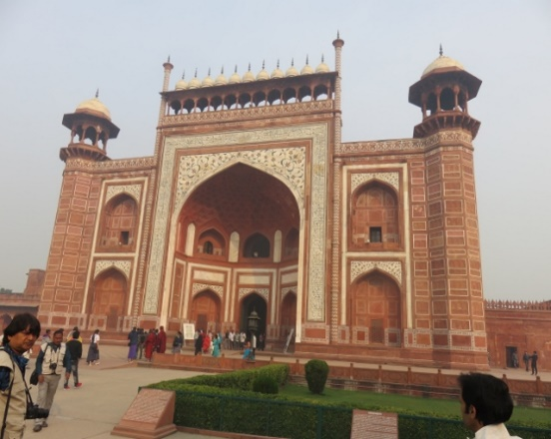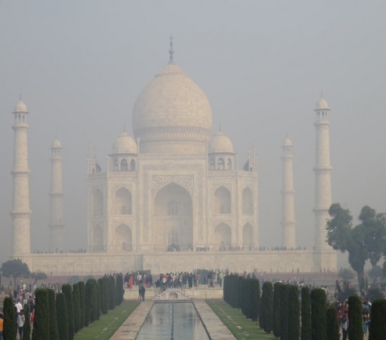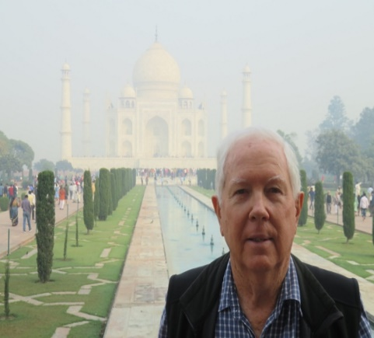
Massive entrance gate to Taj Mahal main view through haze Alan close up with the Taj Mahal
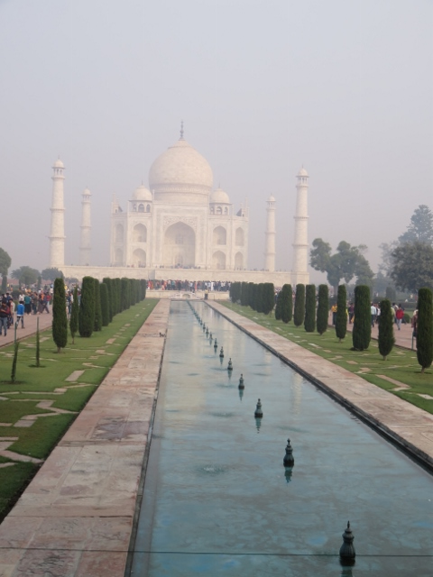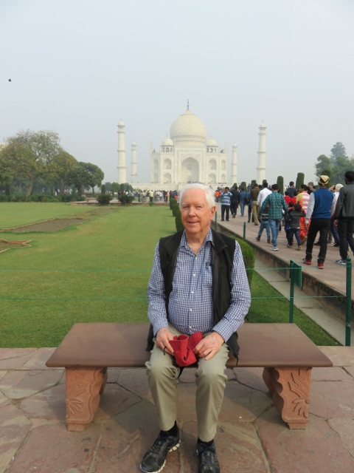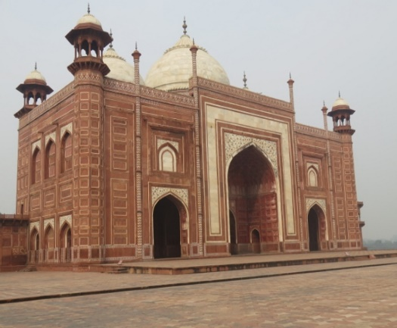
Water feature at front of Taj Mahal Alan on Princess Dianna’s seat Mosque at left hand side of monument.
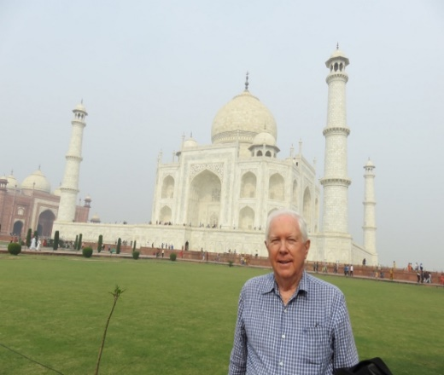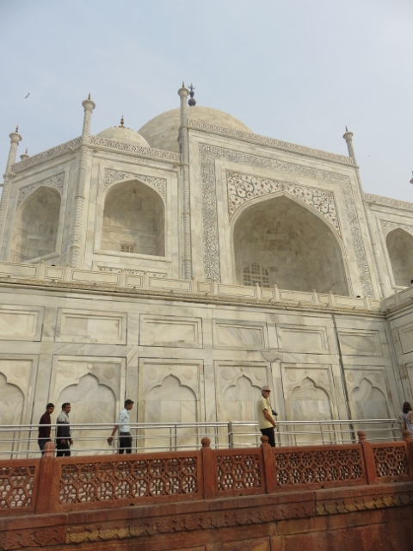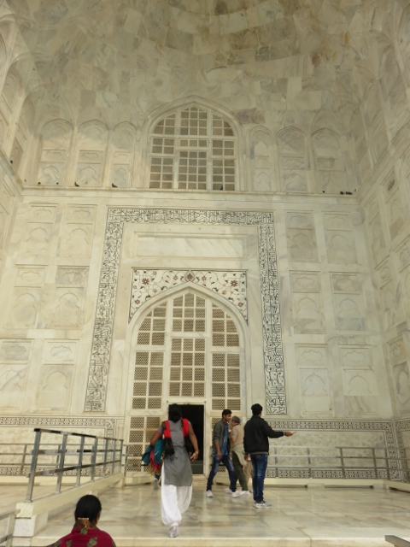
Taj Mahal from RHS with Mosque on left photo taken from in front entrance gate to interior.
After lunch the next stop was at a marble inlay artistic place. Here the group were once again shown the skills of the craftsmen and then the hard sell in the sales rooms. Beautiful pieces but not practical to buy because of weight restrictions on air craft going home.
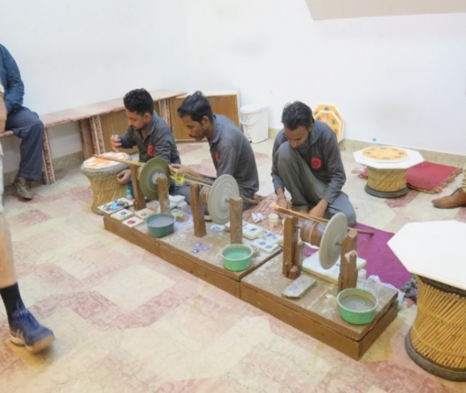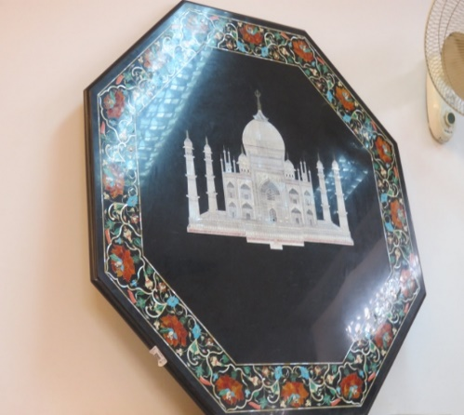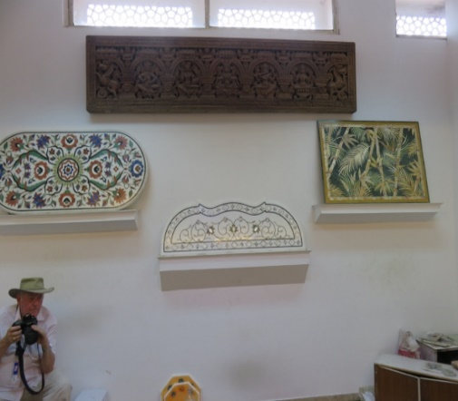
Marble artisans at work their creation displayed fr Max posing beside other samples.
Next stop the Agra Fort known as the “Red Fort” built in 1565 by Emperor Akbar from red sandstone. Grand buildings, marble mosques, stone courtyards and royal chambers abound.
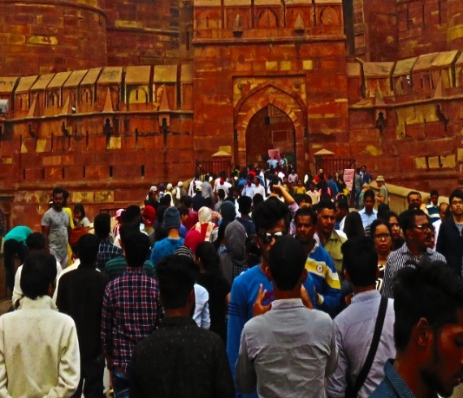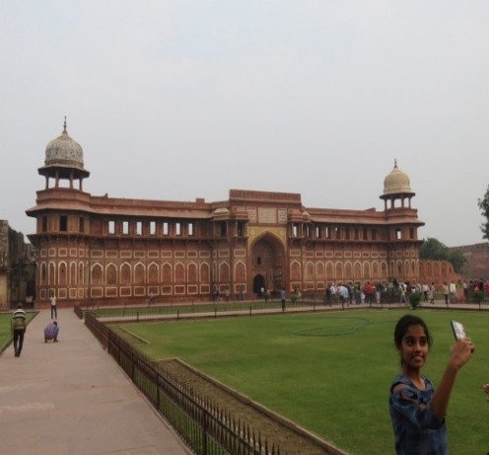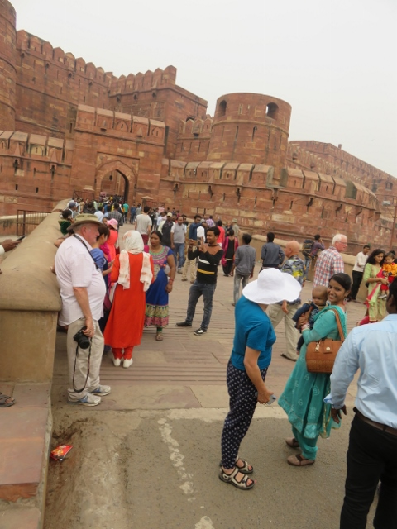
Wall to wall crowd at entrance open space in the centre resting before the next inspection.
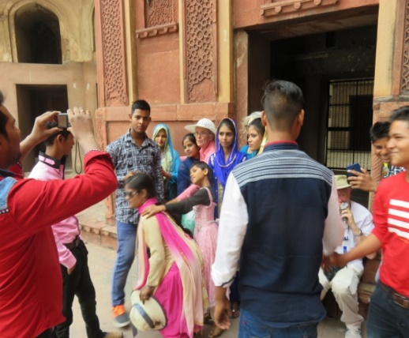 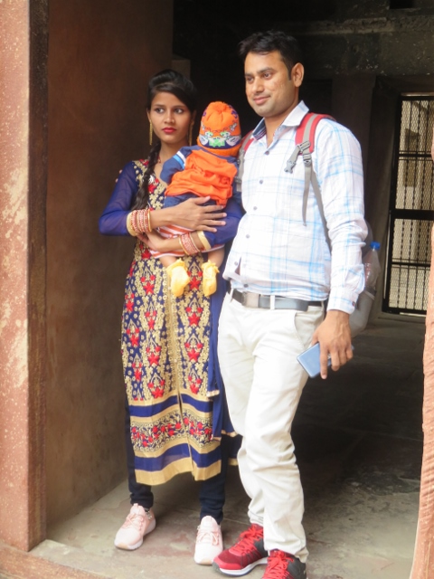 Indians like getting their photos taken!

